Segment Bisector

Definition
# Source: AI Source: Provided by: [Data Path: Persons Table -> ID Column: 1, Name_En Column: Motasem Essam] -> From: [ChatGPT] on [7/25/2026]
A segment bisector is a line, ray, segment, or other geometric object that divides a line segment into two congruent segments.
If a segment bisector divides $\overset{‾}{AB}$at $M$, then:
$$\boxed{AM=MB}$$
Therefore, $M$is the midpoint of $\overset{‾}{AB}$.
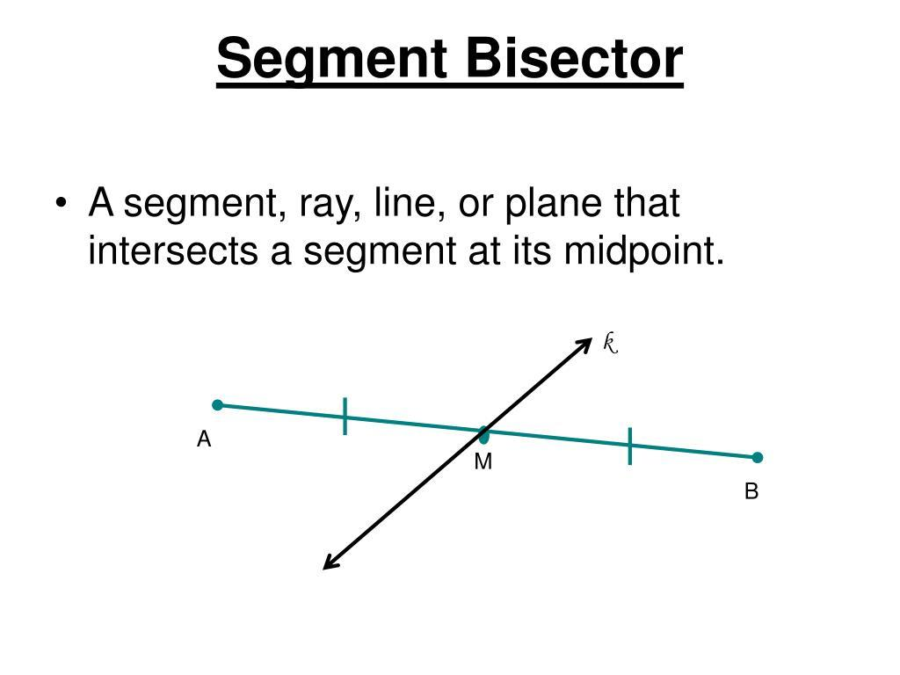
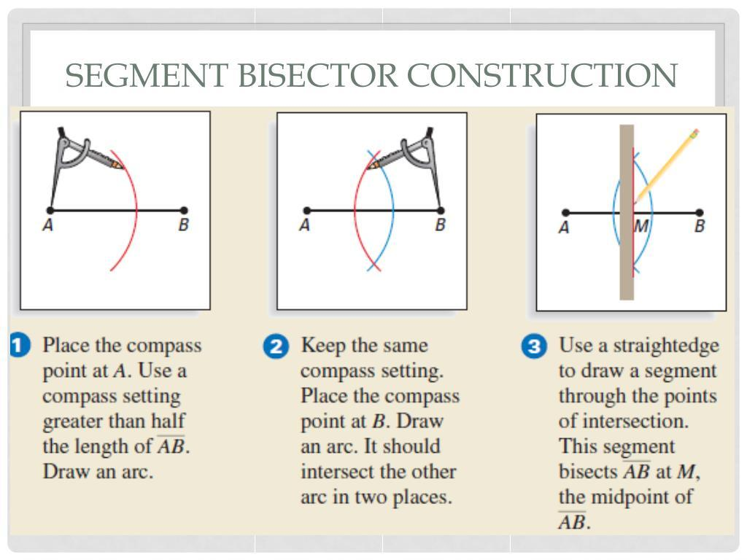
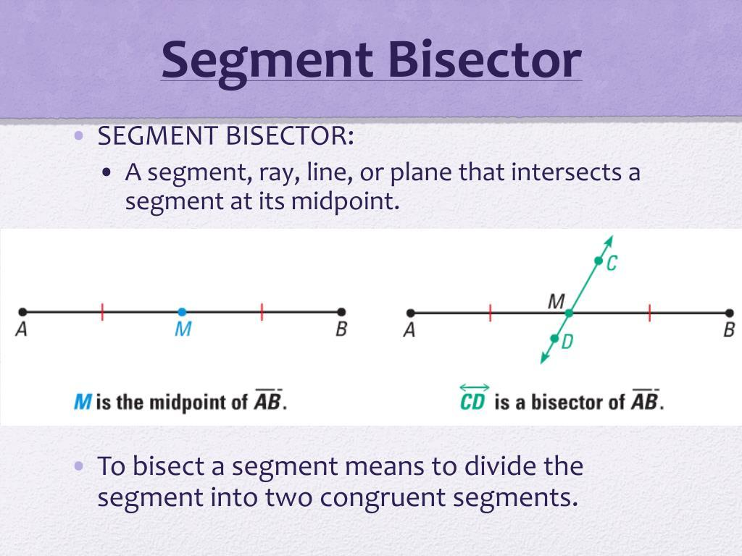
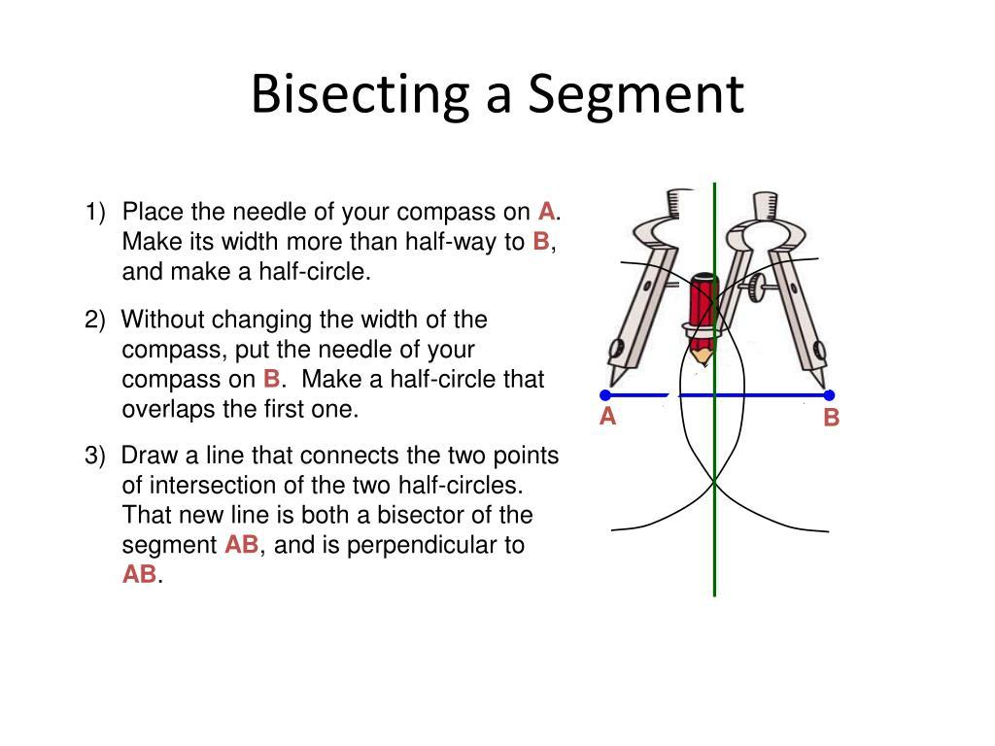
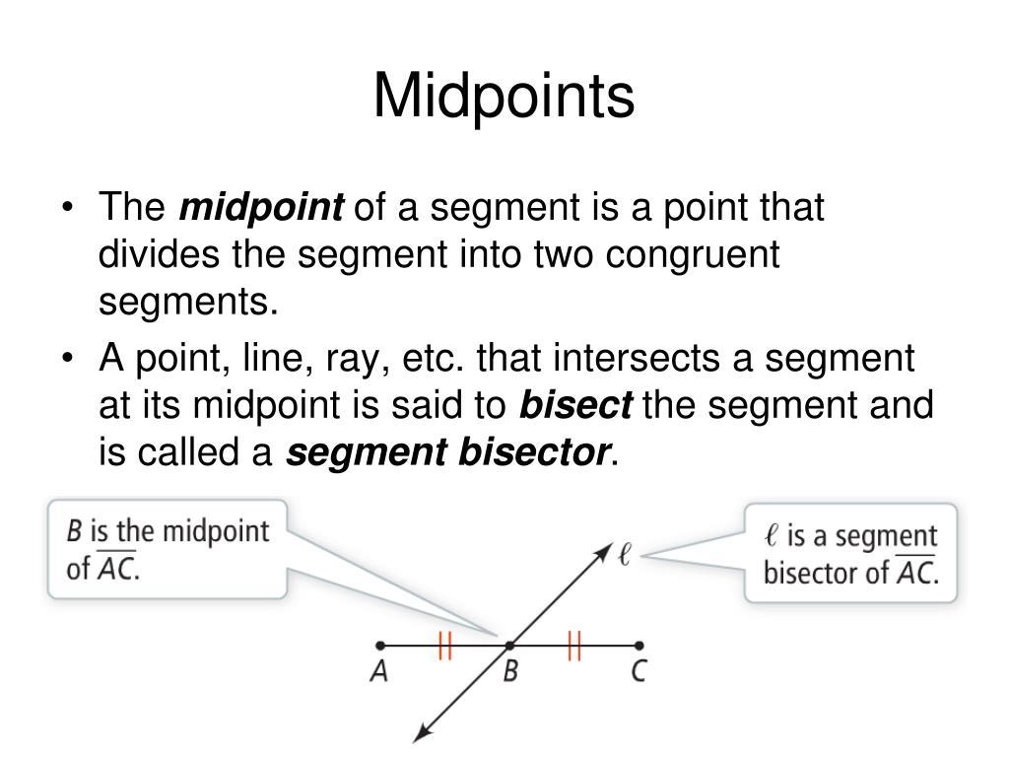

Purpose
# Source: AI Source: Provided by: [Data Path: Persons Table -> ID Column: 1, Name_En Column: Motasem Essam] -> From: [ChatGPT] on [7/25/2026]
A segment bisector is used to:
- Divide a line segment into two equal lengths.
- Locate the midpoint of a segment.
- Construct equal-length segments.
- Construct perpendicular bisectors.
- Solve geometric problems involving segment lengths.
- Find centers of geometric figures.

Basic Configuration
# Source: AI Source: Provided by: [Data Path: Persons Table -> ID Column: 1, Name_En Column: Motasem Essam] -> From: [ChatGPT] on [7/25/2026]
Consider line segment:
$$\overset{‾}{AB}$$
If a bisector intersects it at $M$:
$$A∙⟶M⟶∙B$$
and:
$$AM=MB$$
then the bisector divides $\overset{‾}{AB}$into two congruent segments.
Thus:
$$\boxed{AB=AM+MB}$$
Since:
$$AM=MB$$
we also have:
$$\boxed{AB=2AM=2MB}$$

Fundamental Property
# Source: AI Source: Provided by: [Data Path: Persons Table -> ID Column: 1, Name_En Column: Motasem Essam] -> From: [ChatGPT] on [7/25/2026]
If $M$is the point where a segment bisector divides $\overset{‾}{AB}$, then:
$$\boxed{AM=MB}$$
This is the defining property of a segment bisector.

Segment Bisector vs. Midpoint
# Source: AI Source: Provided by: [Data Path: Persons Table -> ID Column: 1, Name_En Column: Motasem Essam] -> From: [ChatGPT] on [7/25/2026]
These concepts are closely related but refer to different things.
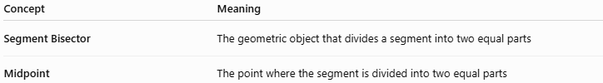
Concept | Meaning
Segment Bisector | The geometric object that divides a segment into two equal parts
Midpoint | The point where the segment is divided into two equal parts
For example:
$$A∙⟶M⟶∙B$$
If:
$$AM=MB$$
then $M$is the midpoint.
A line passing through $M$and dividing the segment into two equal parts is a segment bisector.

Perpendicular Bisector
# Source: AI Source: Provided by: [Data Path: Persons Table -> ID Column: 1, Name_En Column: Motasem Essam] -> From: [ChatGPT] on [7/25/2026]
The perpendicular bisector is the most important special type of segment bisector.
It satisfies two conditions:
- It passes through the midpoint.
- It is perpendicular to the segment.
If $l$is the perpendicular bisector of $\overset{‾}{AB}$:
$$\boxed{AM=MB}$$
and:
$$\boxed{l⊥\overset{‾}{AB}}$$
Therefore:
$$\boxed{∠AMl={90}^{∘}}$$

Example 1: Finding the Two Parts
# Source: AI Source: Provided by: [Data Path: Persons Table -> ID Column: 1, Name_En Column: Motasem Essam] -> From: [ChatGPT] on [7/25/2026]
Suppose:
$$AB=20$$
and $M$is the point where a segment bisector divides $\overset{‾}{AB}$.
Because:
$$AM=MB$$
each part is:
$$AM=MB=\frac{20}{2}$$
Therefore:
$$\boxed{AM=10, MB=10}$$

Example 2: Finding the Whole Segment
# Source: AI Source: Provided by: [Data Path: Persons Table -> ID Column: 1, Name_En Column: Motasem Essam] -> From: [ChatGPT] on [7/25/2026]
Suppose:
$$AM=7$$
and $M$is the midpoint of $\overset{‾}{AB}$.
Since:
$$AM=MB$$
we have:
$$MB=7$$
Therefore:
$$AB=AM+MB \\ AB=7+7 \\ \boxed{AB=14}$$

Example 3: Algebraic Segment Bisector
# Source: AI Source: Provided by: [Data Path: Persons Table -> ID Column: 1, Name_En Column: Motasem Essam] -> From: [ChatGPT] on [7/25/2026]
Suppose $M$bisects $\overset{‾}{AB}$, where:
$$AM=3x+2$$
and:
$$MB=5x-6$$
Because $M$is the midpoint:
$$AM=MB$$
Therefore:
$$3x+2=5x-6 \\ 8=2x \\ x=4$$
Substitute:
$$AM=3\left(4\right)+2=14$$
and:
$$MB=5\left(4\right)-6=14$$
Thus:
$$\boxed{AM=MB=14}$$
and:
$$\boxed{AB=28}$$

Segment Bisector and Segment Addition
# Source: AI Source: Provided by: [Data Path: Persons Table -> ID Column: 1, Name_En Column: Motasem Essam] -> From: [ChatGPT] on [7/25/2026]
A segment bisector can be used together with the Segment Addition Theorem.
If $M$bisects $\overset{‾}{AB}$:
$$AB=AM+MB$$
and:
$$AM=MB$$
Therefore:
$$AB=2AM$$
or:
$$AB=2MB$$
Hence:
$$\boxed{AB=2AM=2MB}$$

Segment Bisector in a Triangle
# Source: AI Source: Provided by: [Data Path: Persons Table -> ID Column: 1, Name_En Column: Motasem Essam] -> From: [ChatGPT] on [7/25/2026]
A segment bisector can divide one of the sides of a triangle into two equal segments.
For example, if $D$bisects $\overset{‾}{BC}$:
$$BD=DC$$
Then $D$is the midpoint of $\overset{‾}{BC}$.
If $A$is connected to $D$, then:
$$\overset{‾}{AD}$$
is a median of the triangle.
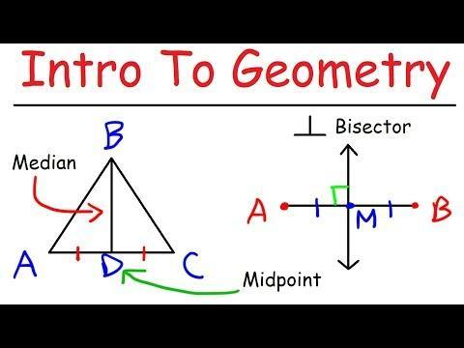
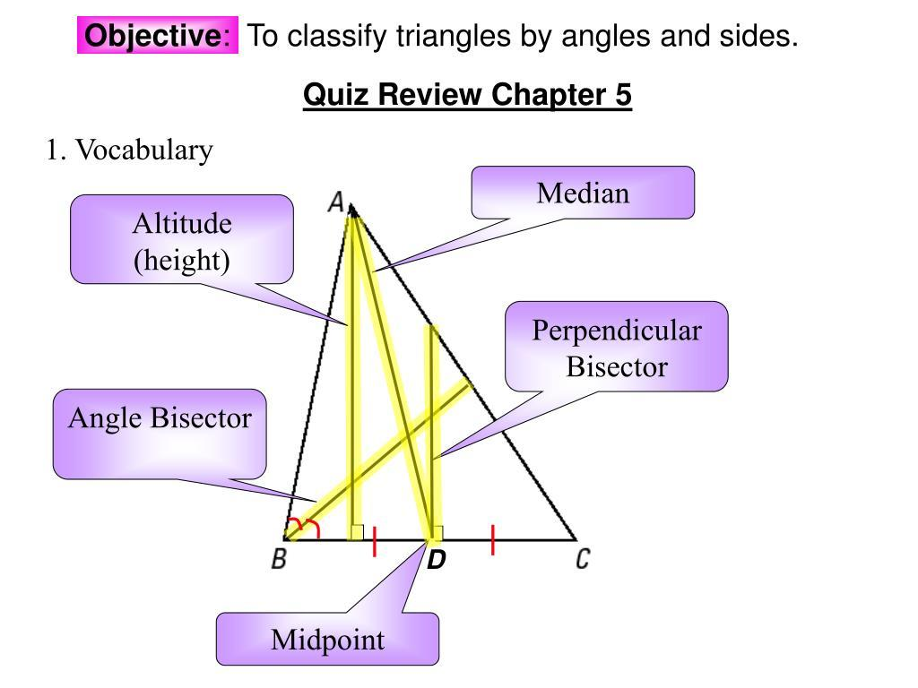
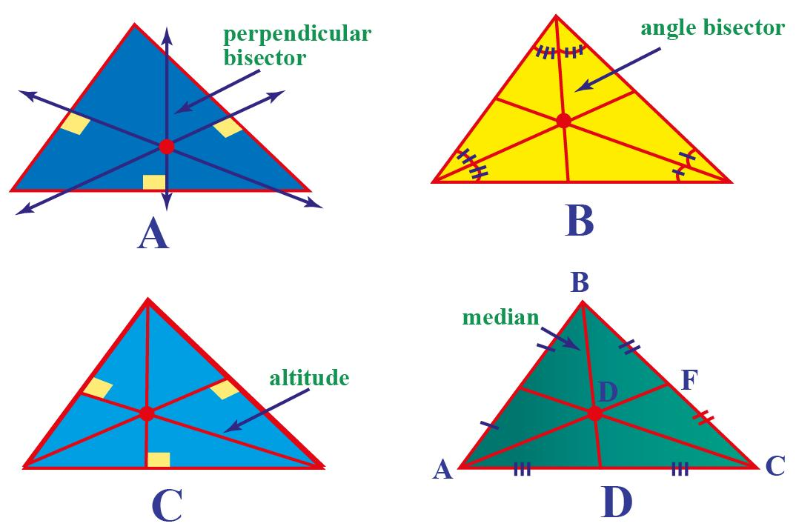
Important
A segment bisector and a median are related but not identical:
- The segment bisector divides a segment into two equal parts.
- A triangle median connects a vertex to the midpoint of the opposite side.

Constructing a Segment Bisector
# Source: AI Source: Provided by: [Data Path: Persons Table -> ID Column: 1, Name_En Column: Motasem Essam] -> From: [ChatGPT] on [7/25/2026]
A segment can be bisected using a ruler and compass.
For a perpendicular bisector:
- Start with segment $\overset{‾}{AB}$.
- Open the compass to more than half of $AB$.
- Draw arcs centered at $A$and $B$.
- The arcs intersect at two points.
- Draw a line through those two intersection points.
- This line passes through the midpoint and is perpendicular to $\overset{‾}{AB}$.
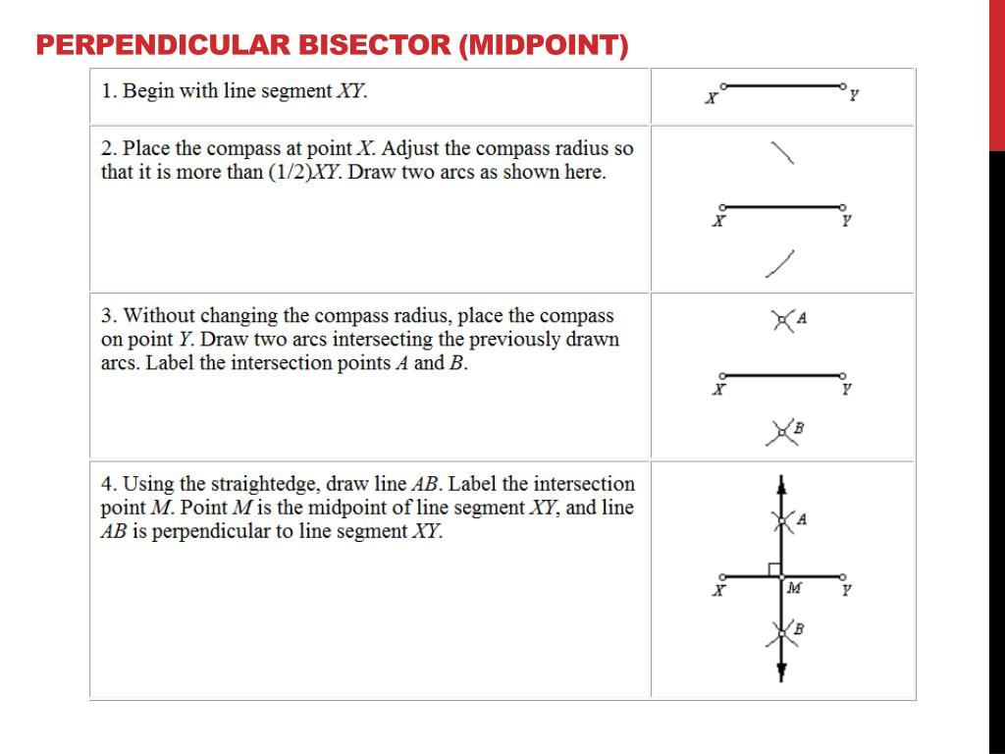
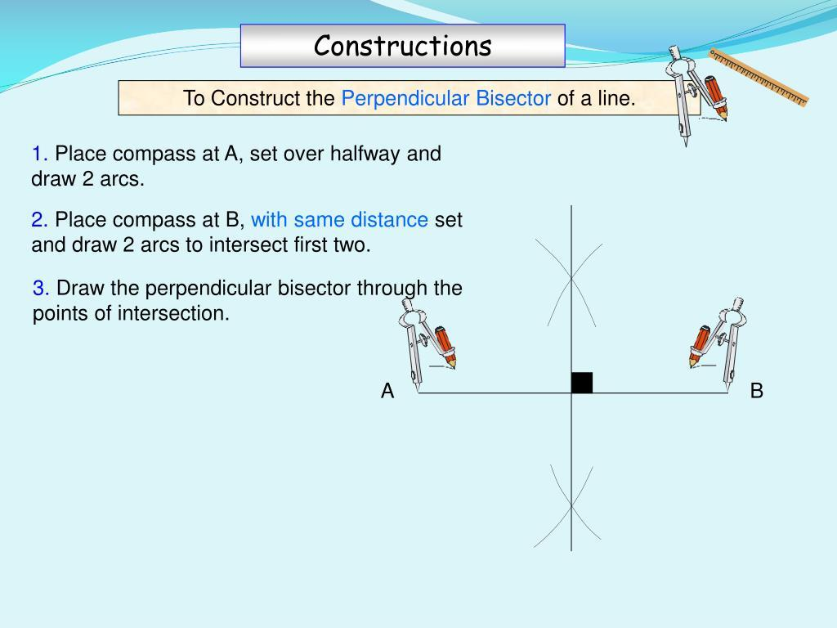
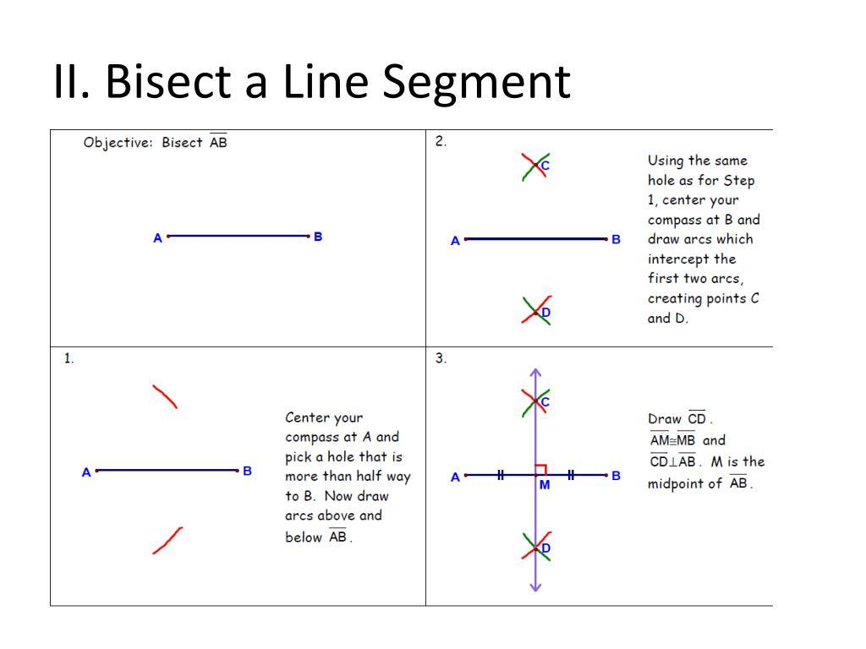

Important Properties
# Source: AI Source: Provided by: [Data Path: Persons Table -> ID Column: 1, Name_En Column: Motasem Essam] -> From: [ChatGPT] on [7/25/2026]
If a segment bisector divides $\overset{‾}{AB}$at $M$:
Property 1 — Equal segments
$$\boxed{AM=MB}$$
Property 2 — Midpoint
$$\boxed{M\text{ is the midpoint of }\overset{‾}{AB}}$$
Property 3 — Equal halves
$$\boxed{AB=2AM=2MB}$$
Property 4 — Perpendicularity only for a perpendicular bisector
A general segment bisector does not have to be perpendicular to the segment.
Only a perpendicular bisector satisfies:
$$\boxed{l⊥\overset{‾}{AB}}$$

Segment Bisector vs. Perpendicular Bisector
# Source: AI Source: Provided by: [Data Path: Persons Table -> ID Column: 1, Name_En Column: Motasem Essam] -> From: [ChatGPT] on [7/25/2026]
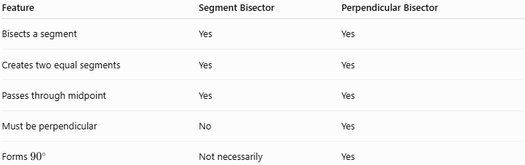
Feature | Segment Bisector | Perpendicular Bisector
Bisects a segment | Yes | Yes
Creates two equal segments | Yes | Yes
Passes through midpoint | Yes | Yes
Must be perpendicular | No | Yes
Forms ${90}^{∘}$ | Not necessarily | Yes

Segment Bisector vs. Angle Bisector
# Source: AI Source: Provided by: [Data Path: Persons Table -> ID Column: 1, Name_En Column: Motasem Essam] -> From: [ChatGPT] on [7/25/2026]
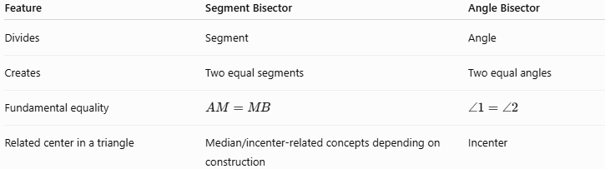
Feature | Segment Bisector | Angle Bisector
Divides | Segment | Angle
Creates | Two equal segments | Two equal angles
Fundamental equality | $$AM=MB$$ | $$∠1=∠2$$
Related center in a triangle | Median/incenter-related concepts depending on construction | Incenter

Relationship with Related Concepts
# Source: AI Source: Provided by: [Data Path: Persons Table -> ID Column: 1, Name_En Column: Motasem Essam] -> From: [ChatGPT] on [7/25/2026]
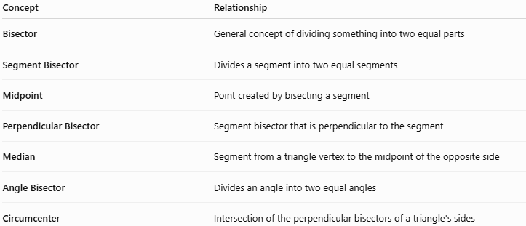
Concept | Relationship
Bisector | General concept of dividing something into two equal parts
Segment Bisector | Divides a segment into two equal segments
Midpoint | Point created by bisecting a segment
Perpendicular Bisector | Segment bisector that is perpendicular to the segment
Median | Segment from a triangle vertex to the midpoint of the opposite side
Angle Bisector | Divides an angle into two equal angles
Circumcenter | Intersection of the perpendicular bisectors of a triangle's sides

Real-World Applications
# Source: AI Source: Provided by: [Data Path: Persons Table -> ID Column: 1, Name_En Column: Motasem Essam] -> From: [ChatGPT] on [7/25/2026]
Segment bisectors are useful in:
- Construction
- Architecture
- Engineering
- Technical drawing
- Surveying
- Computer graphics
- Manufacturing
- Symmetrical design
- Dividing materials into equal lengths
For example, a carpenter can use a segment bisector to locate the exact center of a wooden board.

Advantages
# Source: AI Source: Provided by: [Data Path: Persons Table -> ID Column: 1, Name_En Column: Motasem Essam] -> From: [ChatGPT] on [7/25/2026]
- Provides an exact method for dividing a segment equally.
- Makes midpoint construction straightforward.
- Helps create symmetrical designs.
- Supports geometric constructions.
- Forms the basis for perpendicular-bisector constructions.
- Useful in triangle geometry and coordinate geometry.

Limitations
# Source: AI Source: Provided by: [Data Path: Persons Table -> ID Column: 1, Name_En Column: Motasem Essam] -> From: [ChatGPT] on [7/25/2026]
- A general segment bisector does not necessarily have to be perpendicular to the segment.
- A segment bisector should not be confused with an angle bisector.
- A segment bisector alone does not determine the circumcenter; the relevant construction uses perpendicular bisectors.

Key Points
# Source: AI Source: Provided by: [Data Path: Persons Table -> ID Column: 1, Name_En Column: Motasem Essam] -> From: [ChatGPT] on [7/25/2026]
- A segment bisector divides a line segment into two congruent segments.
- If $M$bisects $\overset{‾}{AB}$:
$$\boxed{AM=MB}$$
- $M$is therefore the midpoint of $\overset{‾}{AB}$.
- A segment bisector does not necessarily form a ${90}^{∘}$angle.
- A perpendicular bisector is a special type of segment bisector.
- If $M$is the midpoint:
$$\boxed{AB=2AM=2MB}$$
- In a triangle, a segment bisector can identify the midpoint of a side; connecting that midpoint to the opposite vertex produces a median.

Conclusion
# Source: AI Source: Provided by: [Data Path: Persons Table -> ID Column: 1, Name_En Column: Motasem Essam] -> From: [ChatGPT] on [7/25/2026]
A segment bisector is a geometric object that divides a line segment into two equal-length parts. The point where the division occurs is the midpoint. A perpendicular bisector is a special case in which the bisector is also perpendicular to the segment, making segment bisectors an important foundation for constructions involving midpoints, medians, symmetry, and circumcenters.

